STARAGILE MAVEN ASSIGNMENT -1

1. **Creating a Maven Java Project**:
   * Open Eclipse IDE.
   * Go to File > New > Maven Project.
   * Select "Create a simple project (skip archetype selection)" and click "Next".
   * Enter the following details:
     + Group Id: com.assignment
     + Artifact Id: my-assignment
     + Version: (anything you like)
     + Packaging: jar
   * Click "Finish" to create the Maven project.

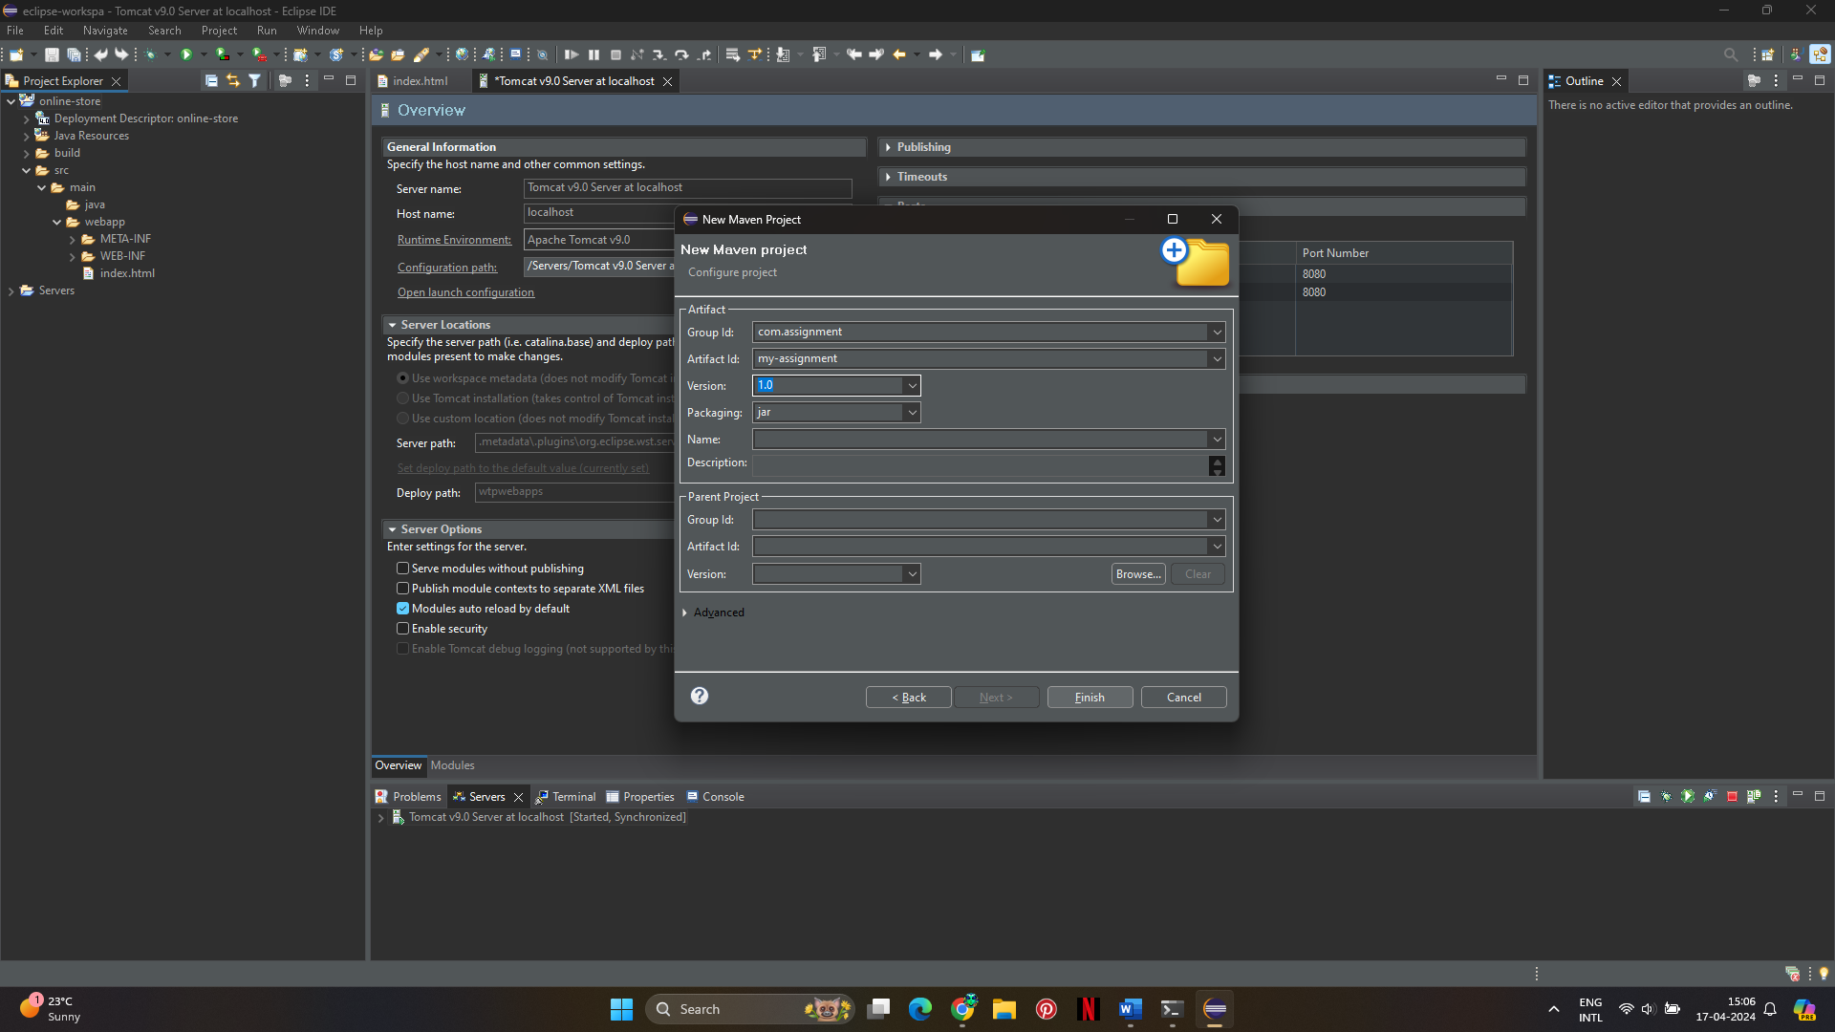

1. **Run Maven Commands**:
   * Maven clean.

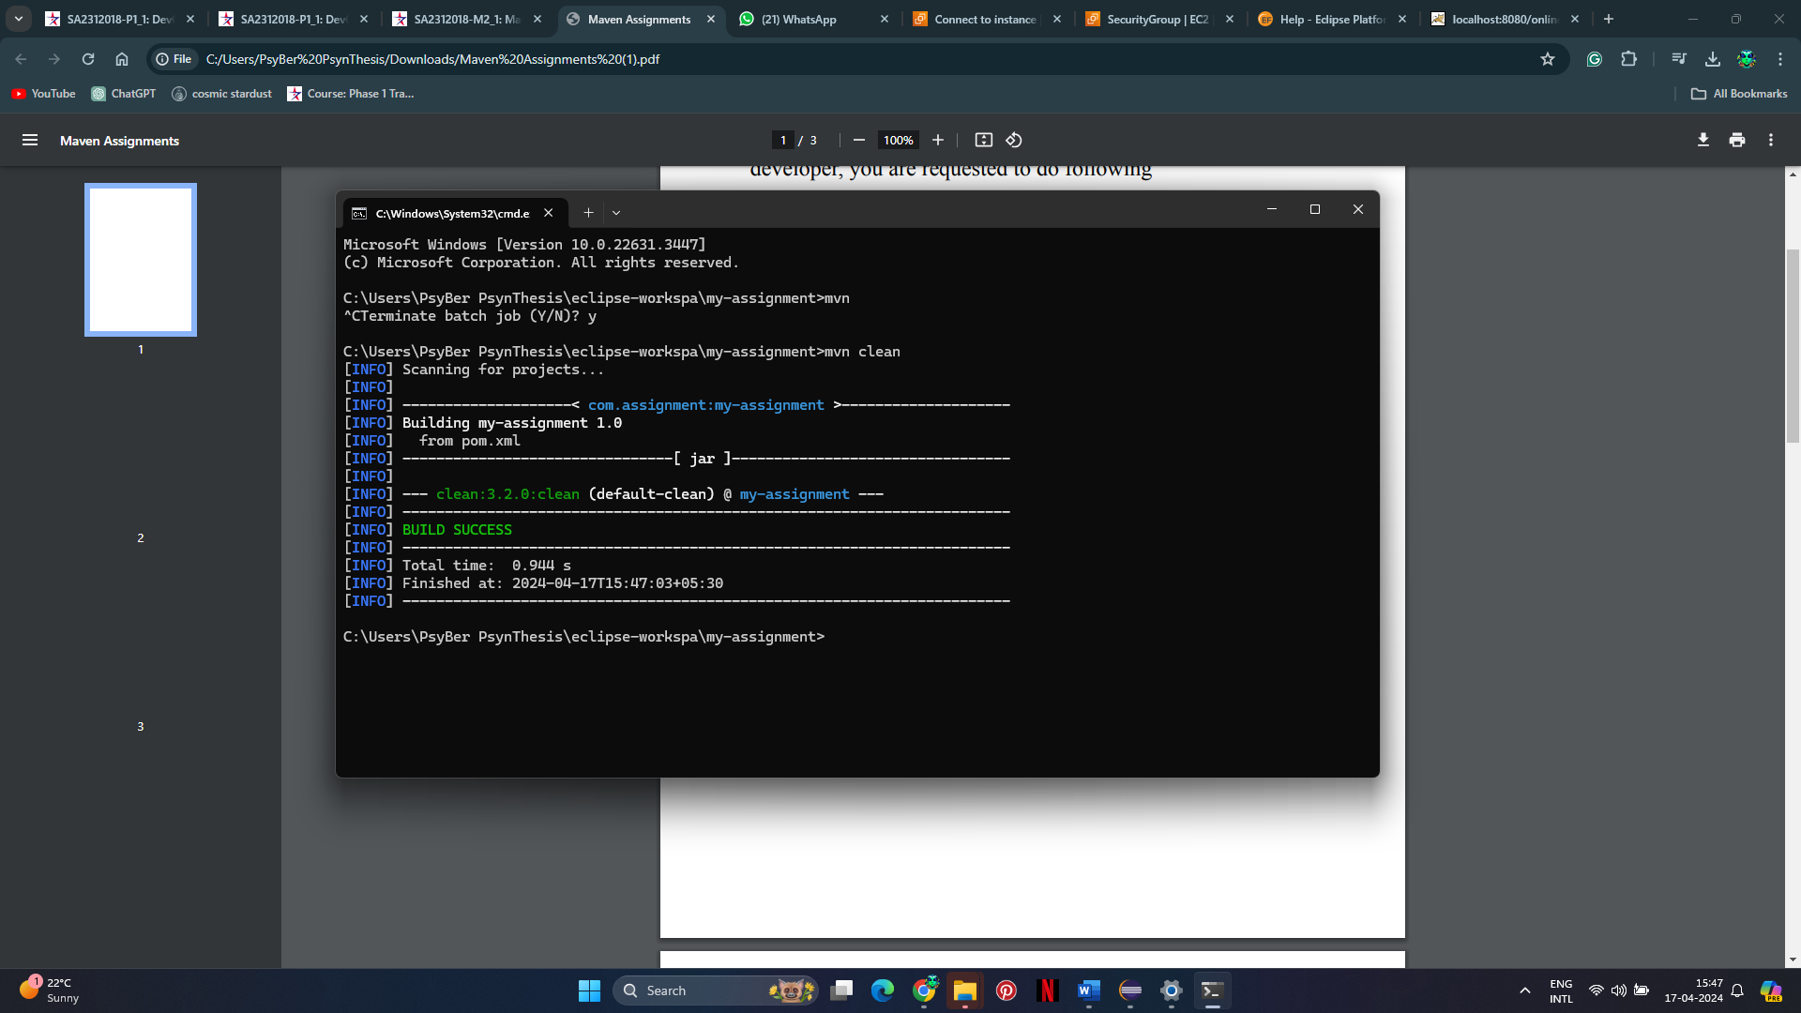

This command cleans the target directory, removing all compiled classes and resources.

* + Maven compile.

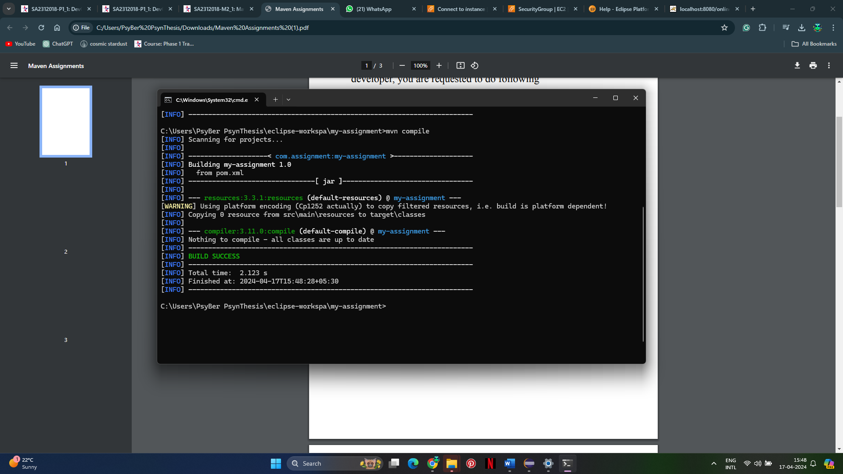

This command compiles the source code of the project.

* + Maven test.

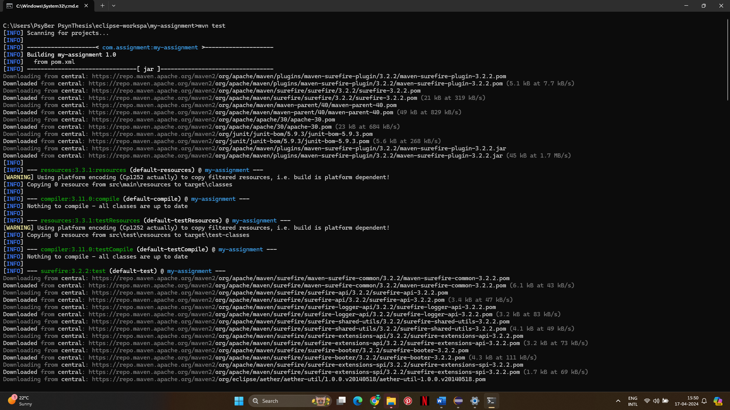

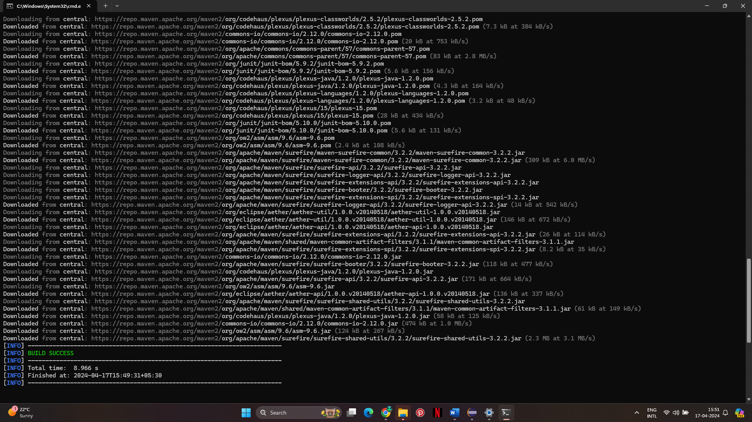

This command runs the unit tests in the project.

* + Maven package.

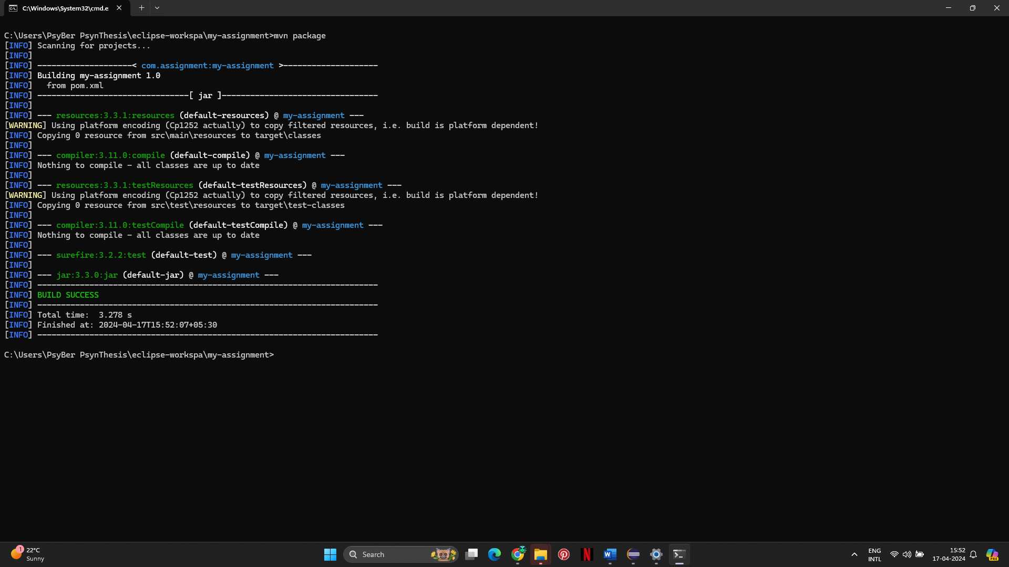

This command packages the compiled code and resources into a distributable format, such as a JAR file.

* + Maven install.

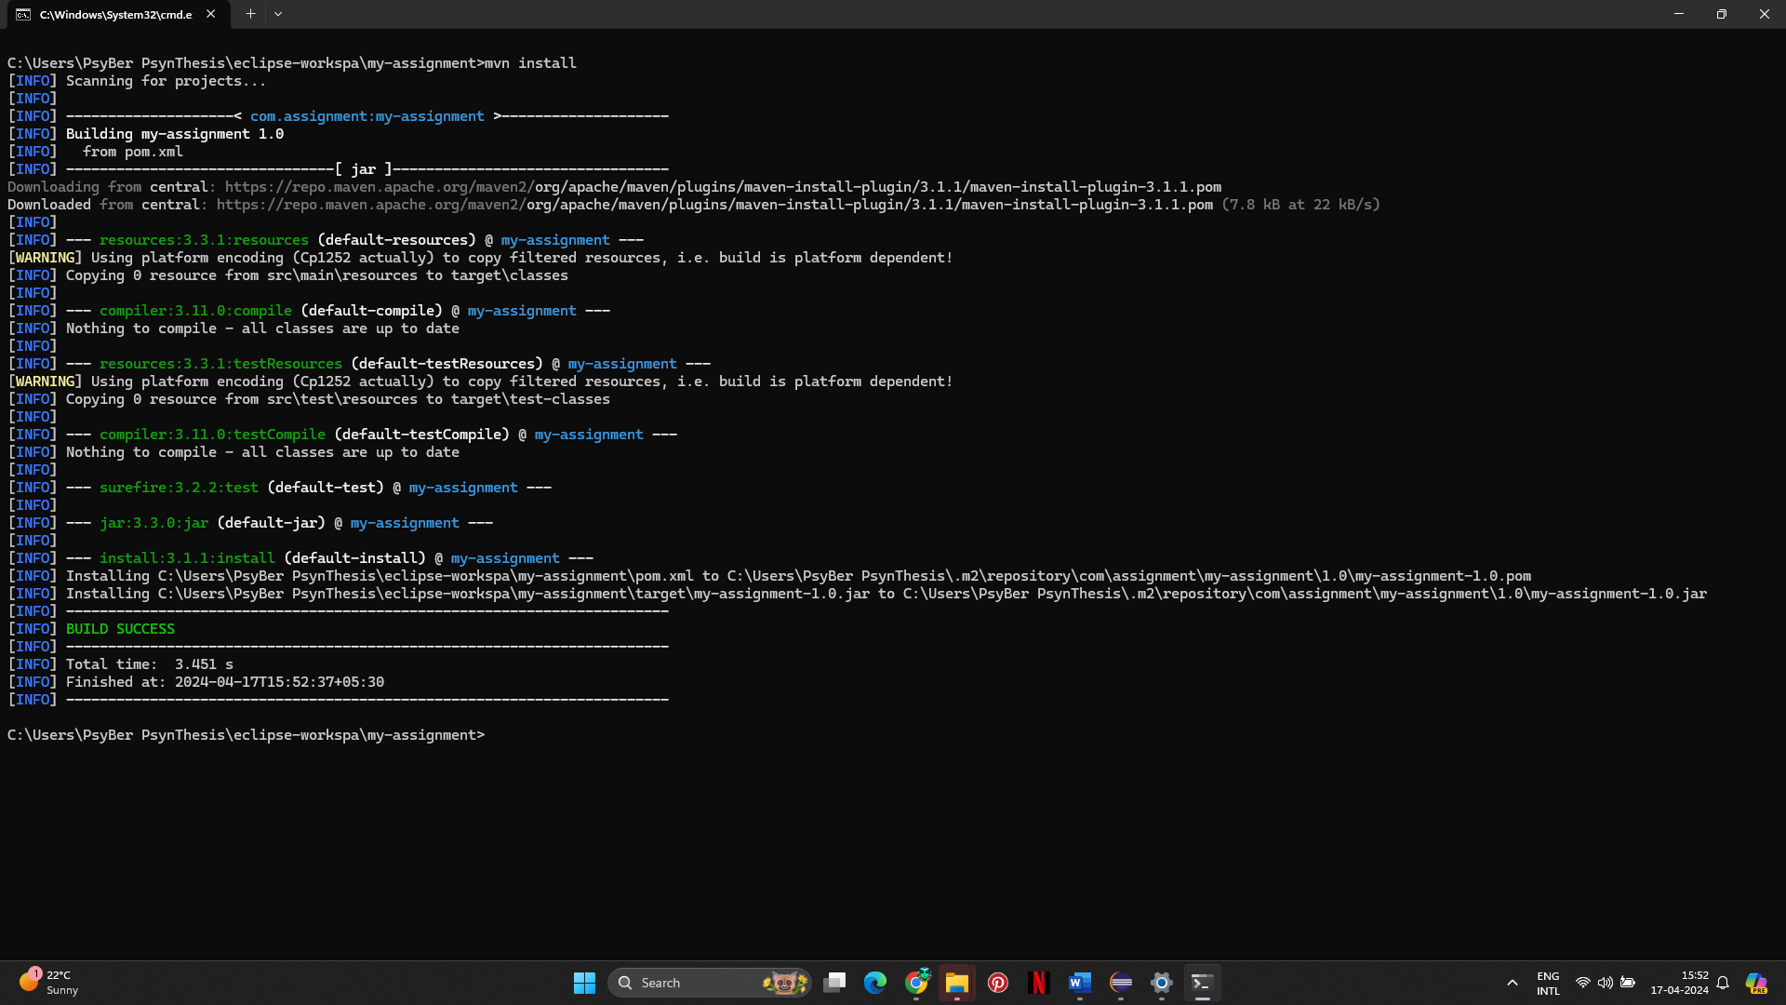

This command installs the packaged artifact into the local Maven repository, making it available to other projects locally.

* + Maven clean package.

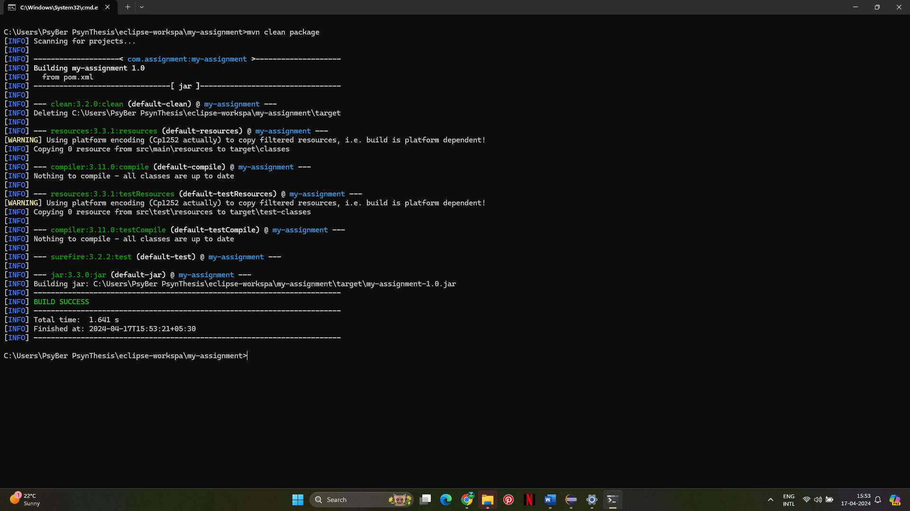

This command first cleans the project, removing any existing compiled code and resources, and then packages the code into a JAR file.